Concept Document
Rally Run Portfolio

Group Name – GAKK
Members:
Aaron Hopkins (1208798)
Grant William Neal (1226997)
Katie Wood (1025249)
Kieran Lee (1116649)

Contents
Contents 1
Introduction 1
Description 2
Key Features 2
Target Audience 2
Concept Art 2
References 5

Introduction
Multimedia Authoring is a way of presenting digital media and collecting it in a way that it is easy to manipulate and add interactivity, to allow an application to be developed (Encyclopedia.jrank.org, 2015). Examples of multimedia authoring could be a game or an interactive story.
For this portfolio task we have been put into a group of 4 in order to create a 3D interactive rich internet application. The purpose of this task is to work together as a group to improve our knowledge and experience when working with the software we will be using to create the application both individually and as part of a group. As a group we decided that we will be creating a game called Rally Run, the software we will be using to develop the game is 3DS Max modelling studio and three.js JavaScript platform.
Rally Run will be an outdoor racing game, where the user has to control a vehicle to collect multiple rings, each ring that is collected adds a point to the number of rings collected. There will be a timer that is initialised when the play button is pressed. Once all rings are collected, the game finishes and the time will stop. The quicker the rings are collected the lower the overall time will be.

Description
To describe Rally Run, it is a game whereby a vehicle is controlled by the player around a dirt track, the vehicle that will be used is a car. When the web page loads, there will be a play button that the user will press when they are ready to play. When the game starts, a timer will begin. The vehicle will be controlled by the use of certain keys on the keyboard, the camera will follow the car as it is navigated by the user. First off is the W key, the W key will accelerate the car to a top speed, allowing the vehicle to move in a forward motion. Secondly will be the controls for turning the vehicle which will be A and D. The A key will turn the vehicle Left, and the D key will turn the vehicle right. Another key will be the S key which will slow the vehicle down and allow it to reverse. An additional key would be the Spacebar which will act as the hand break for the vehicle, allowing the rally to stop quickly. And finally the last Key will be Shift. The Shift key will be a temporary boost of speed. Players will drive round on a plane using these keys to complete objectives around the map.
Whilst driving around on the track, players will need to look out for rings, collecting these rings will add a point onto the numbers of rings collected, there will be 10 rings to collect throughout the track, once all of these rings have been collected the game will end and the timer will stop. The final time will be presented to the user, allowing them to see the total time taken for them to complete the collection of the rings. Once the game is over, along with the score then will be a replay and exit button displayed. The replay button, will allow the user to replay the game, without having to reload the browser when pressed, and when the exit button is pressed the browser will shut down.

Key Features
- Interactivity of car using keyboard
- Collection of Interactive objects
- Car Sound

Target Audience
The target audience for Rally Run will be for ages 11- 21 and others players interested in driving games. We have chosen this age group because we feel this age group was the most interested with racing games, knowing people who are this age ourselves. Our goals and motivation for this application are to create a competitive game, which will interest the users, and make them want to get the lowest time possible.

Concept Art
Figure 1, shows the car that we have created for our prototype, using 3ds max studio and 3 different textures. These textures are a metal texture for the car frame, a glass texture for the car windows and a rubber textire for the wheels. The textures can be seen clearly in figure 2.
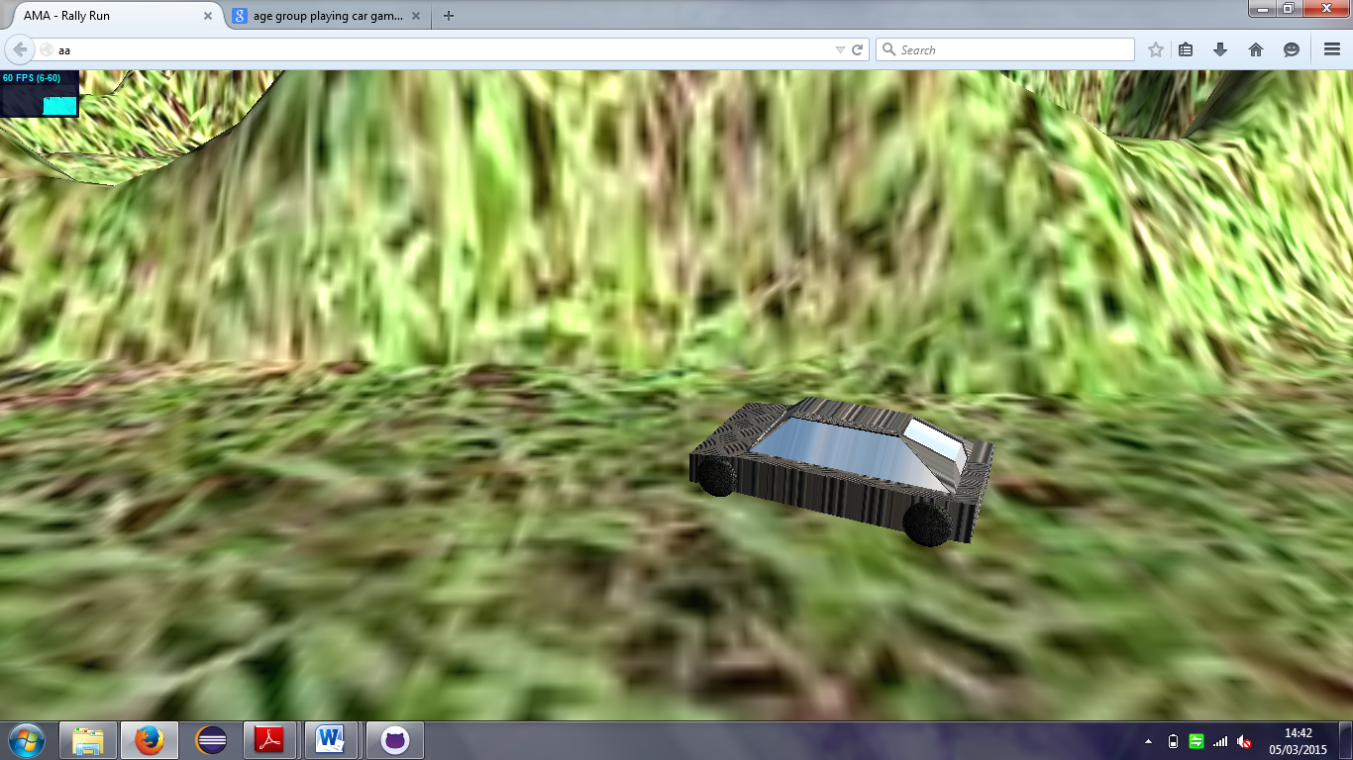
Figure 1 – Car with the terrain
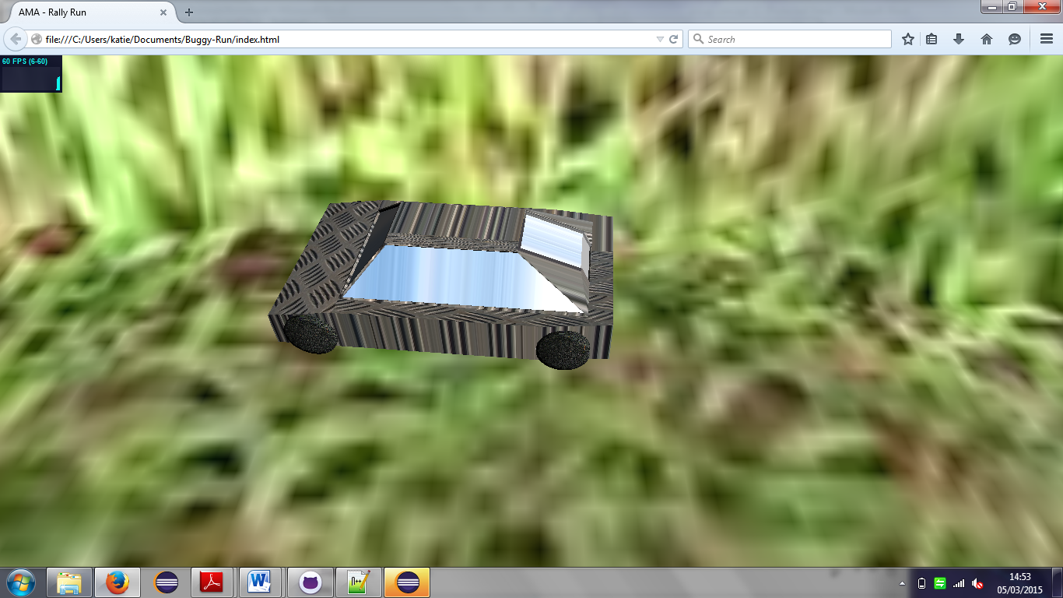

Figure 2- Car with the textures
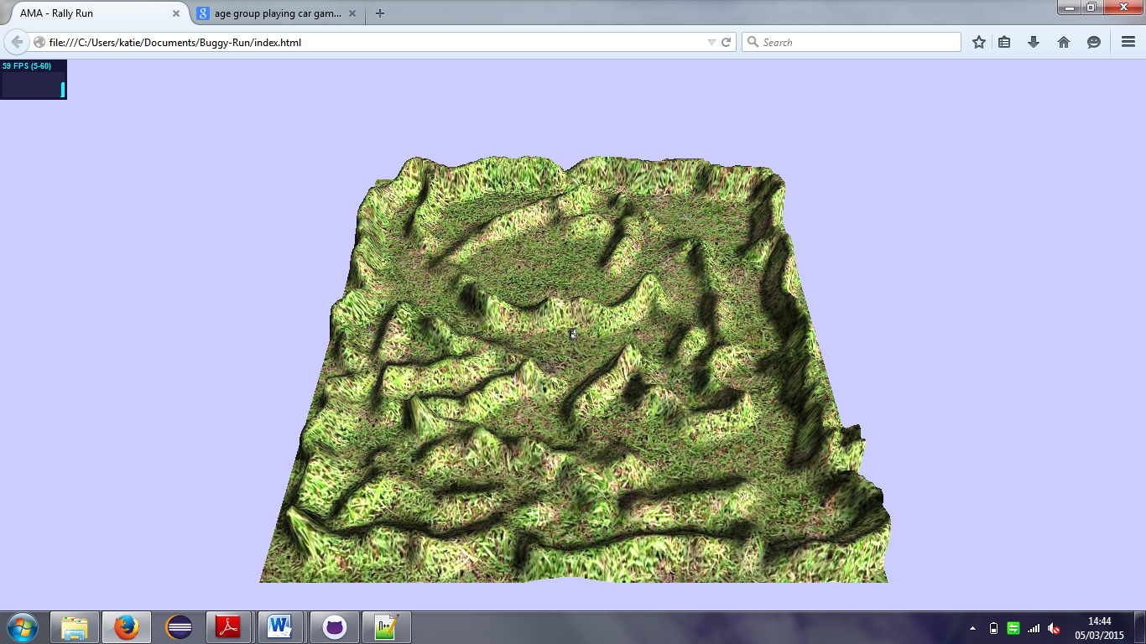
Figure 3- terrain
Figure 3, Shows the terrain which we will be using for the track, we will be adding a dirt track into this which the car will navigate around.

References
Encyclopedia.jrank.org, (2015) Multimedia Authoring - Introduction, Who is the Author?, Authoring Dimensions, Authoring Processes, Movement Oriented Design (MOD), Conclusion. [online]. [Accessed 2 March 2015]. Available at: <http://encyclopedia.jrank.org/articles/pages/6807/Multimedia-Authoring.html>.

